Course: ITD 2343 OOP Using C# Grade **_______**

Instructor: Mark Pranger

Student Name: Cristhian Carcamo

Due Date: 3/5/2025

Gradebook Comments: Copy the Gradebook comments and paste them here

## Section 2 - Week 4 to Week 7 Programming Lab - Cristhian Carcamo

## IDE Experience

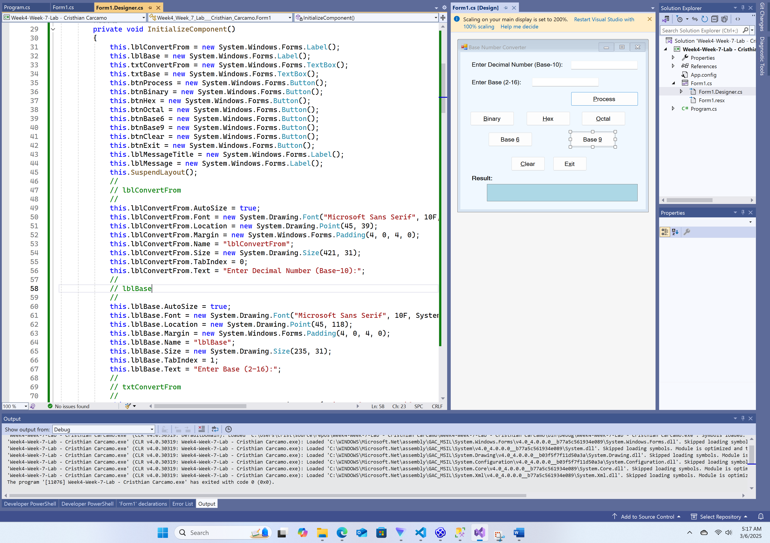

Program running

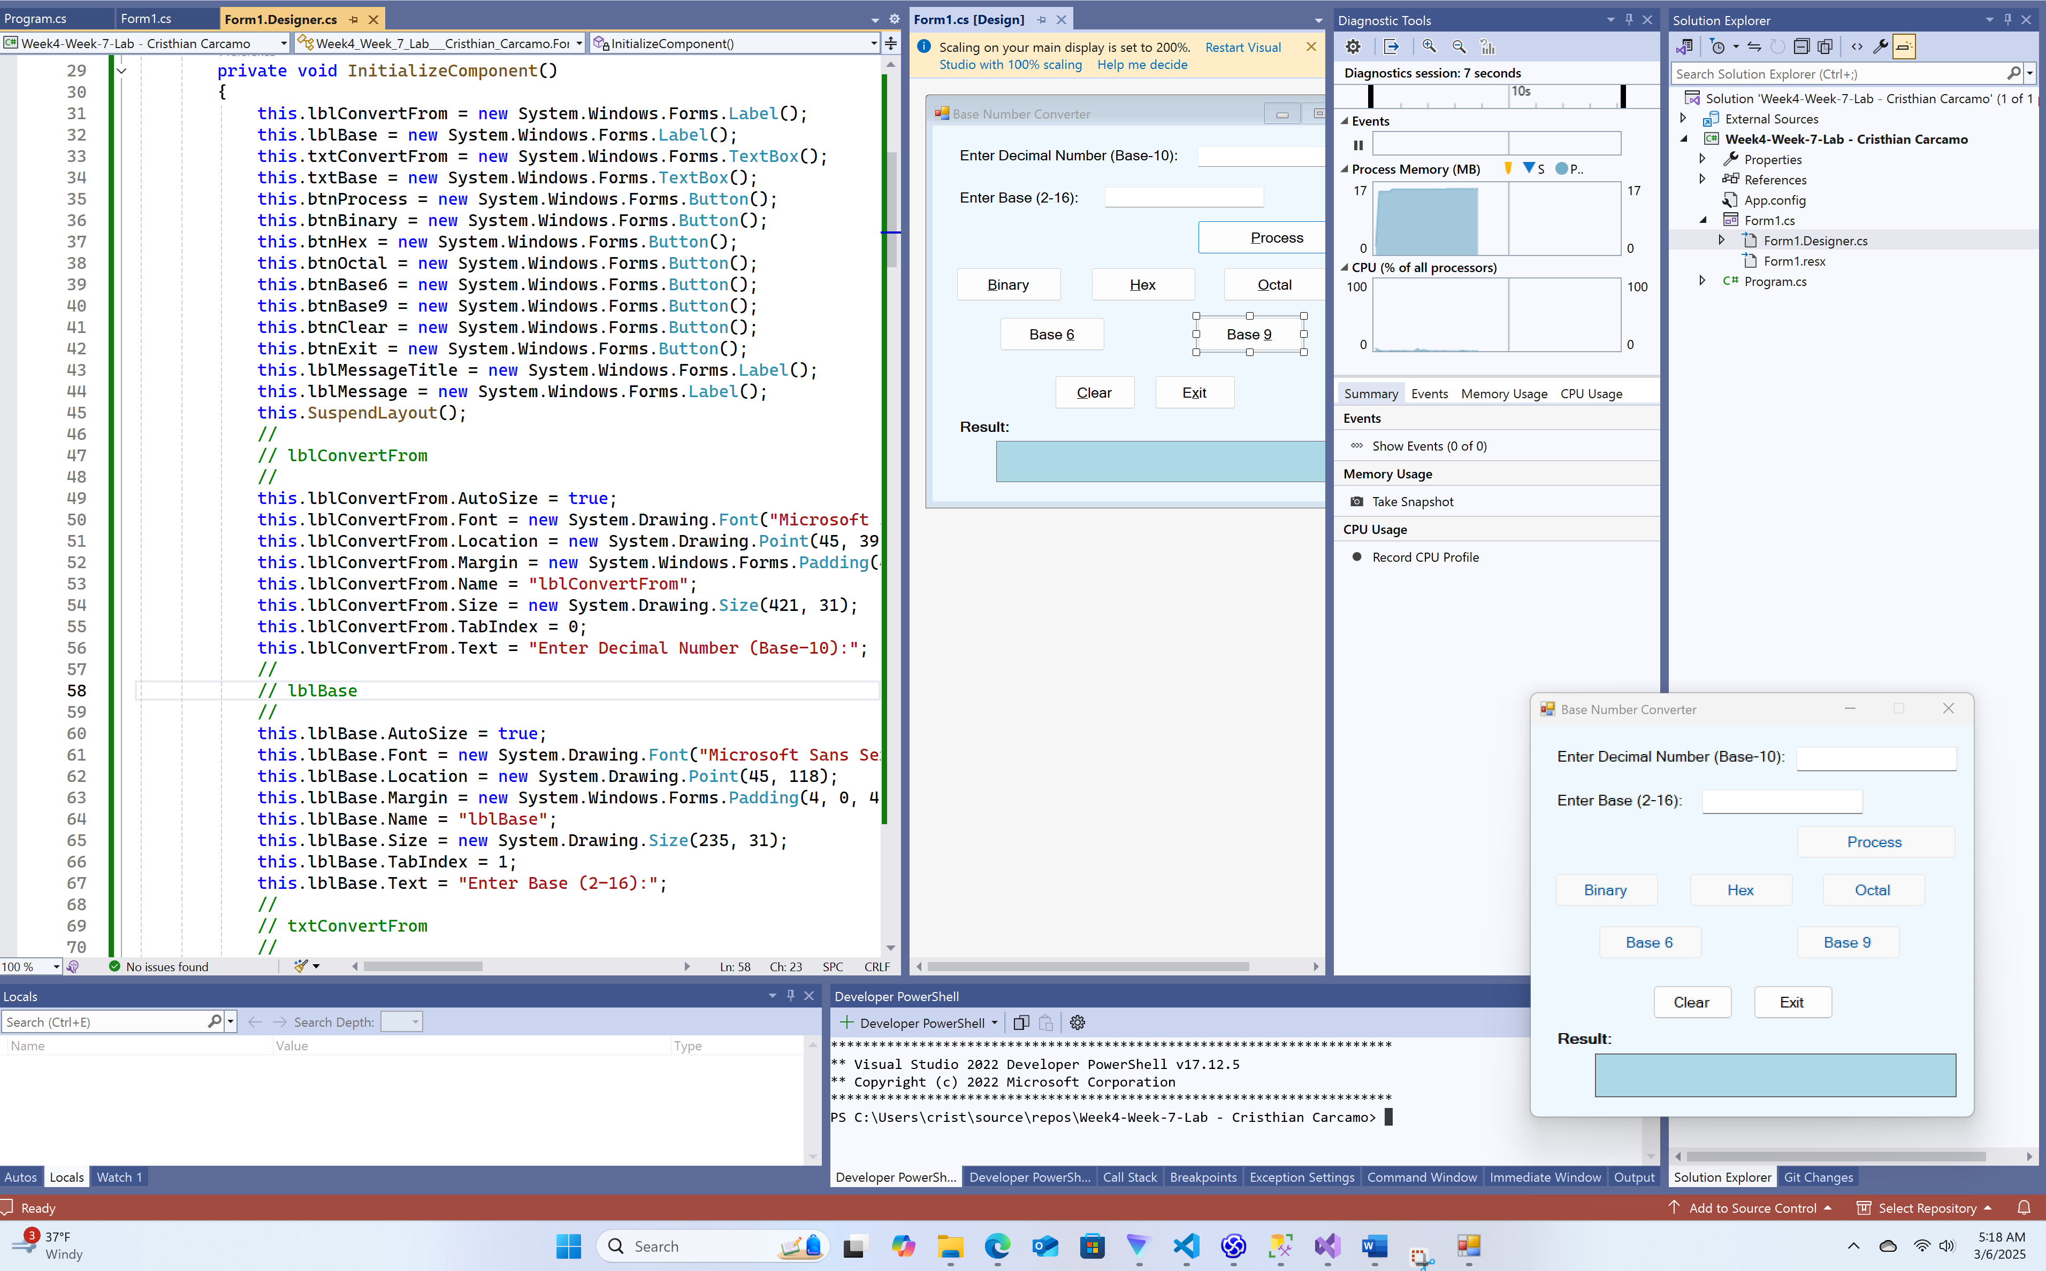

Convert the current year to base 5

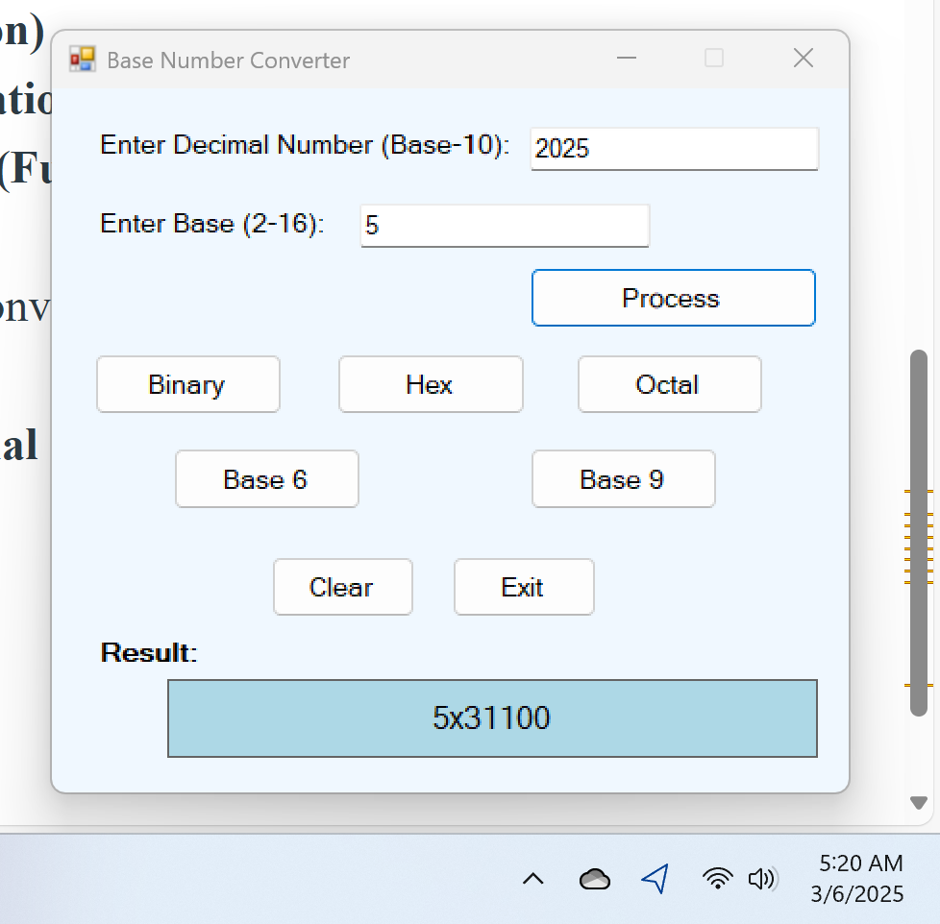

Convert the current year to base 6

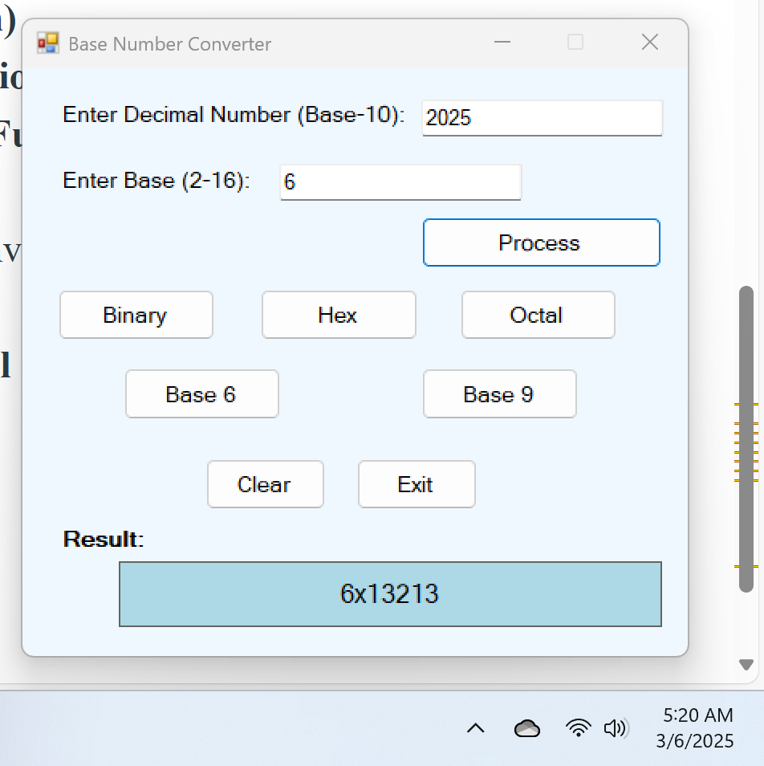

Convert the current year to base 9

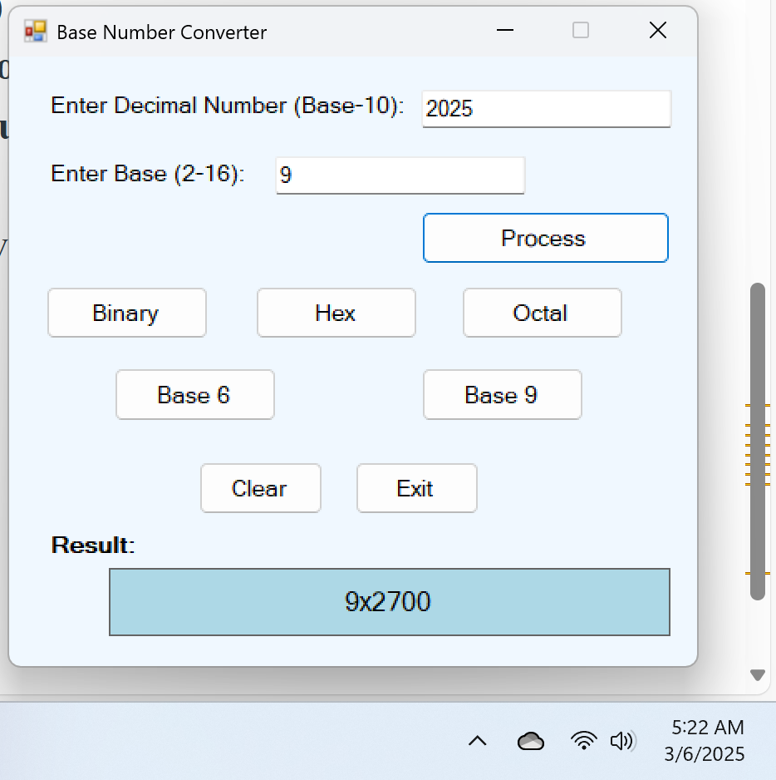

Convert the current year to base 16

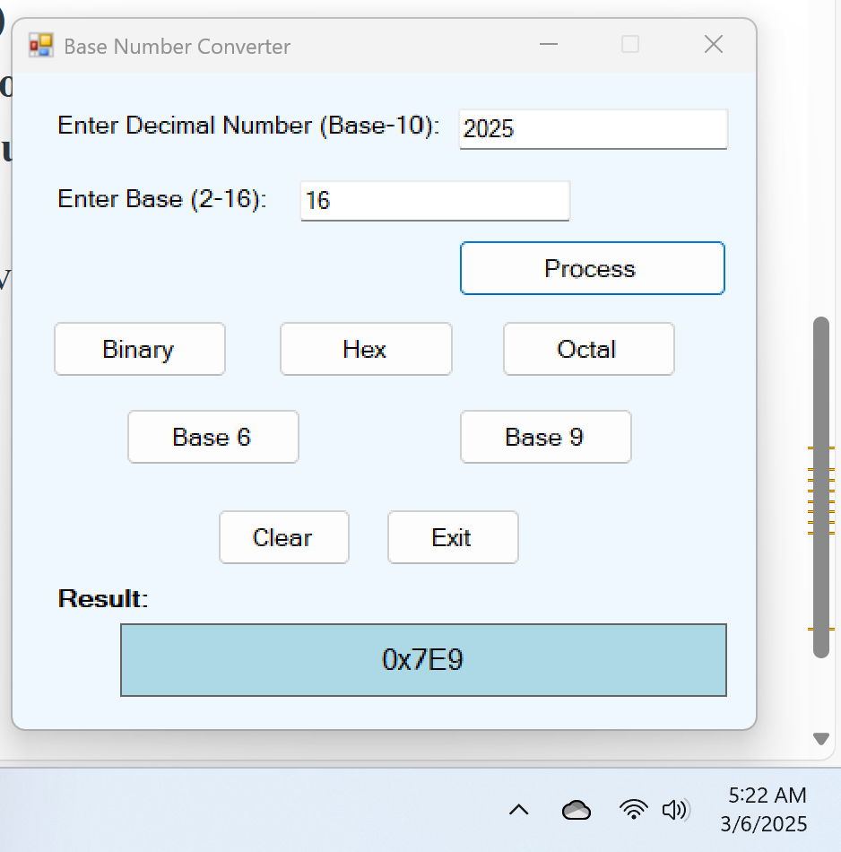

Convert the current year to base 2

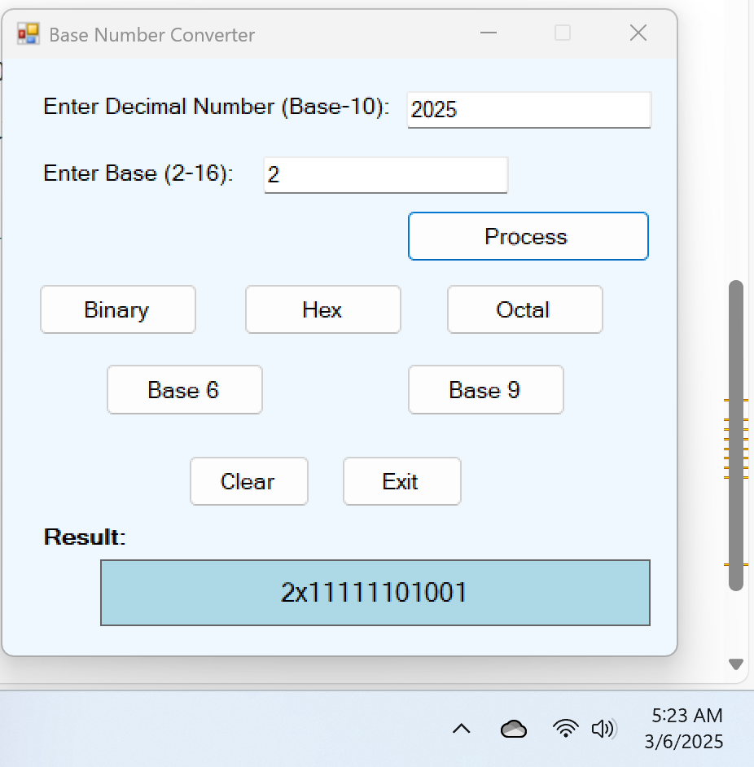

Error with decimal number in base

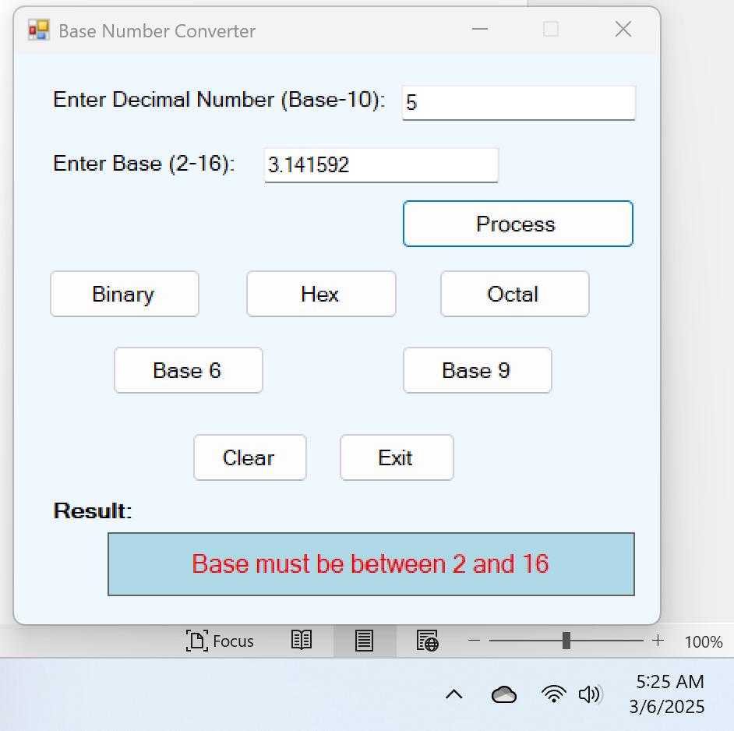

Error with decimal in textbox

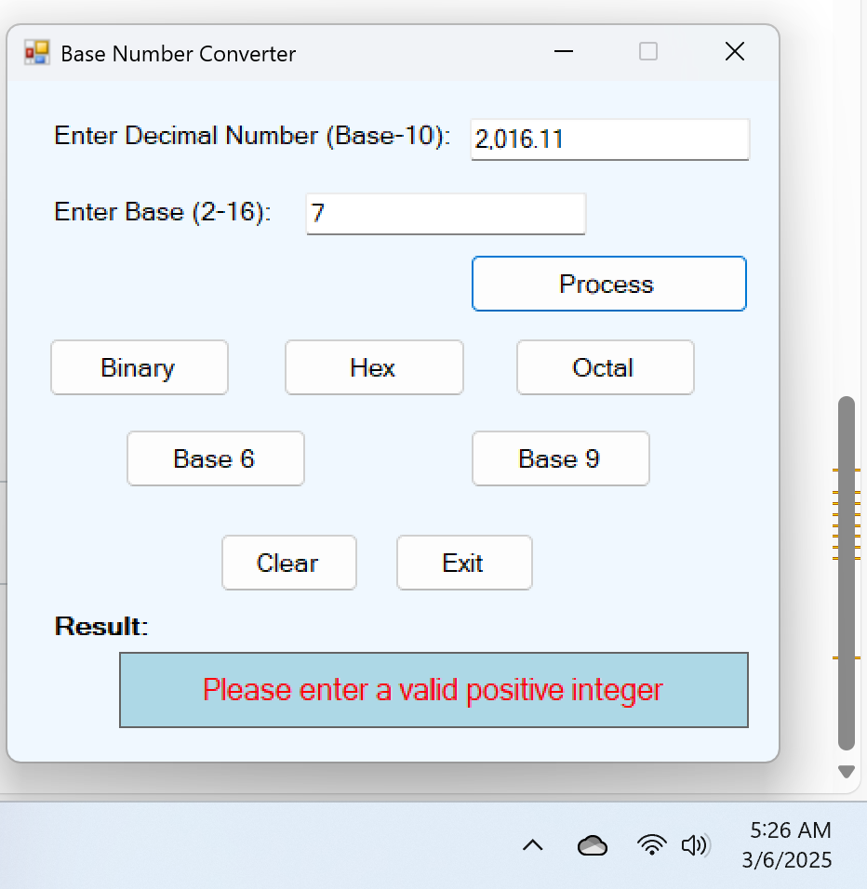

What will do this I wonder error

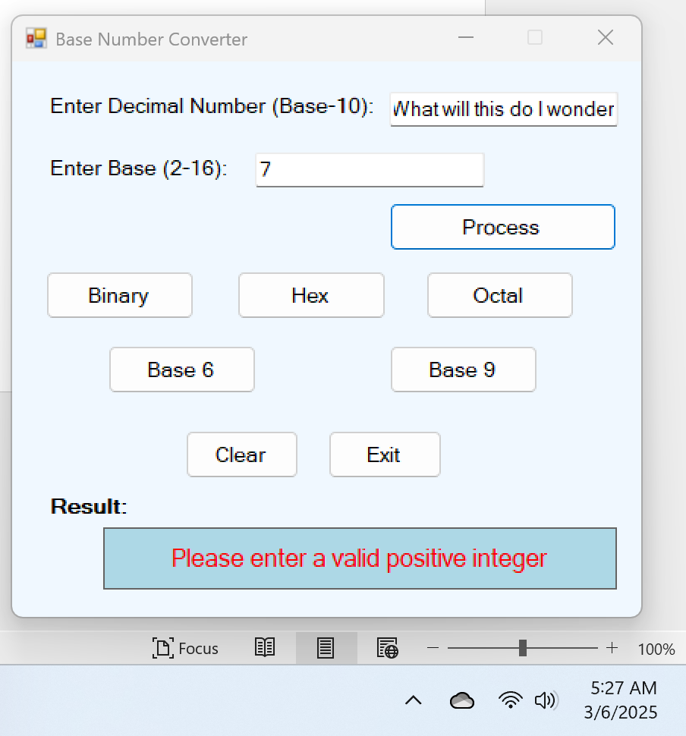

Eleven text in base box error

